Task 5:-Capture and Analyze Network Traffic Using Wireshark.

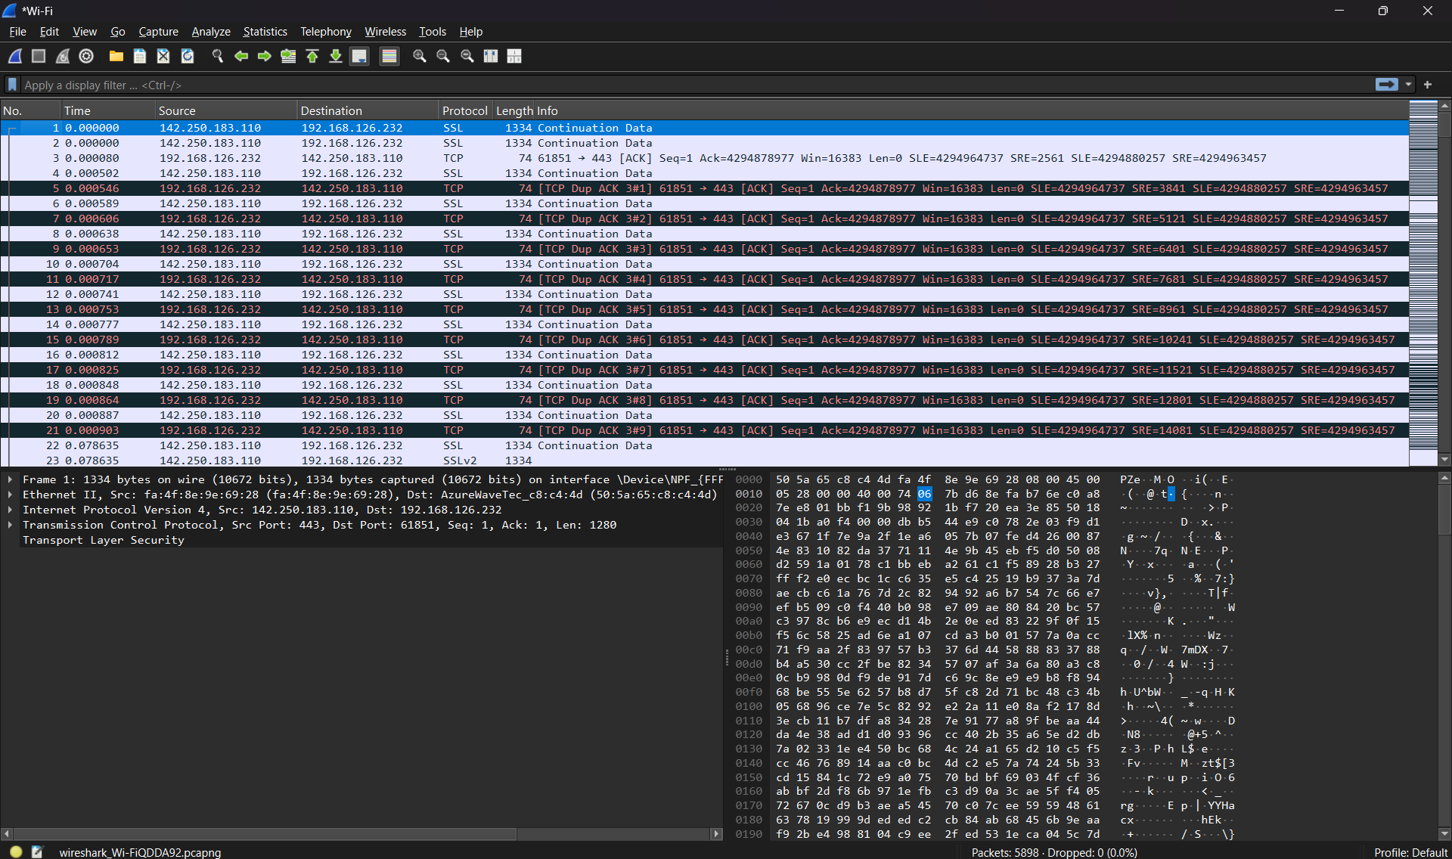

Started analyzing packets

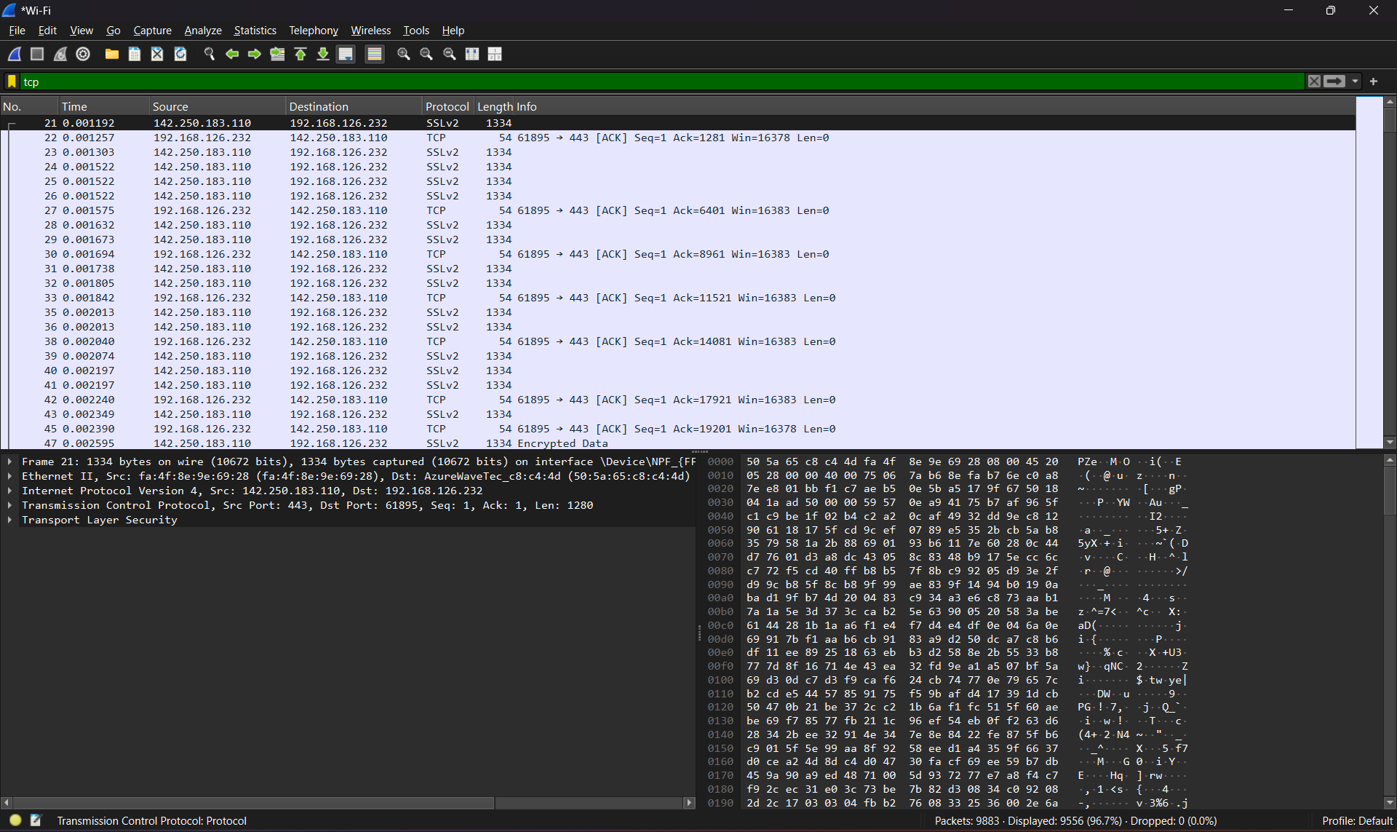

Filltering TCP protocol

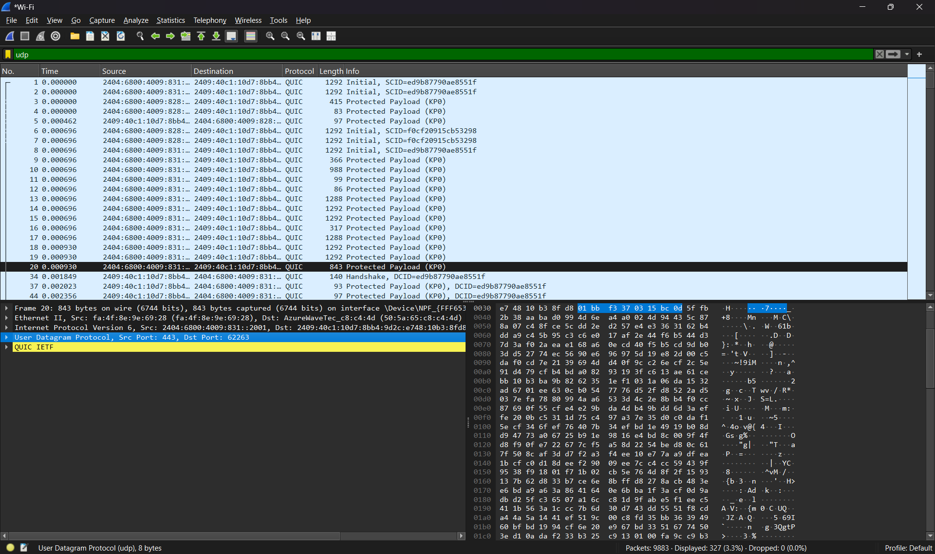

Filtering UDP protocol

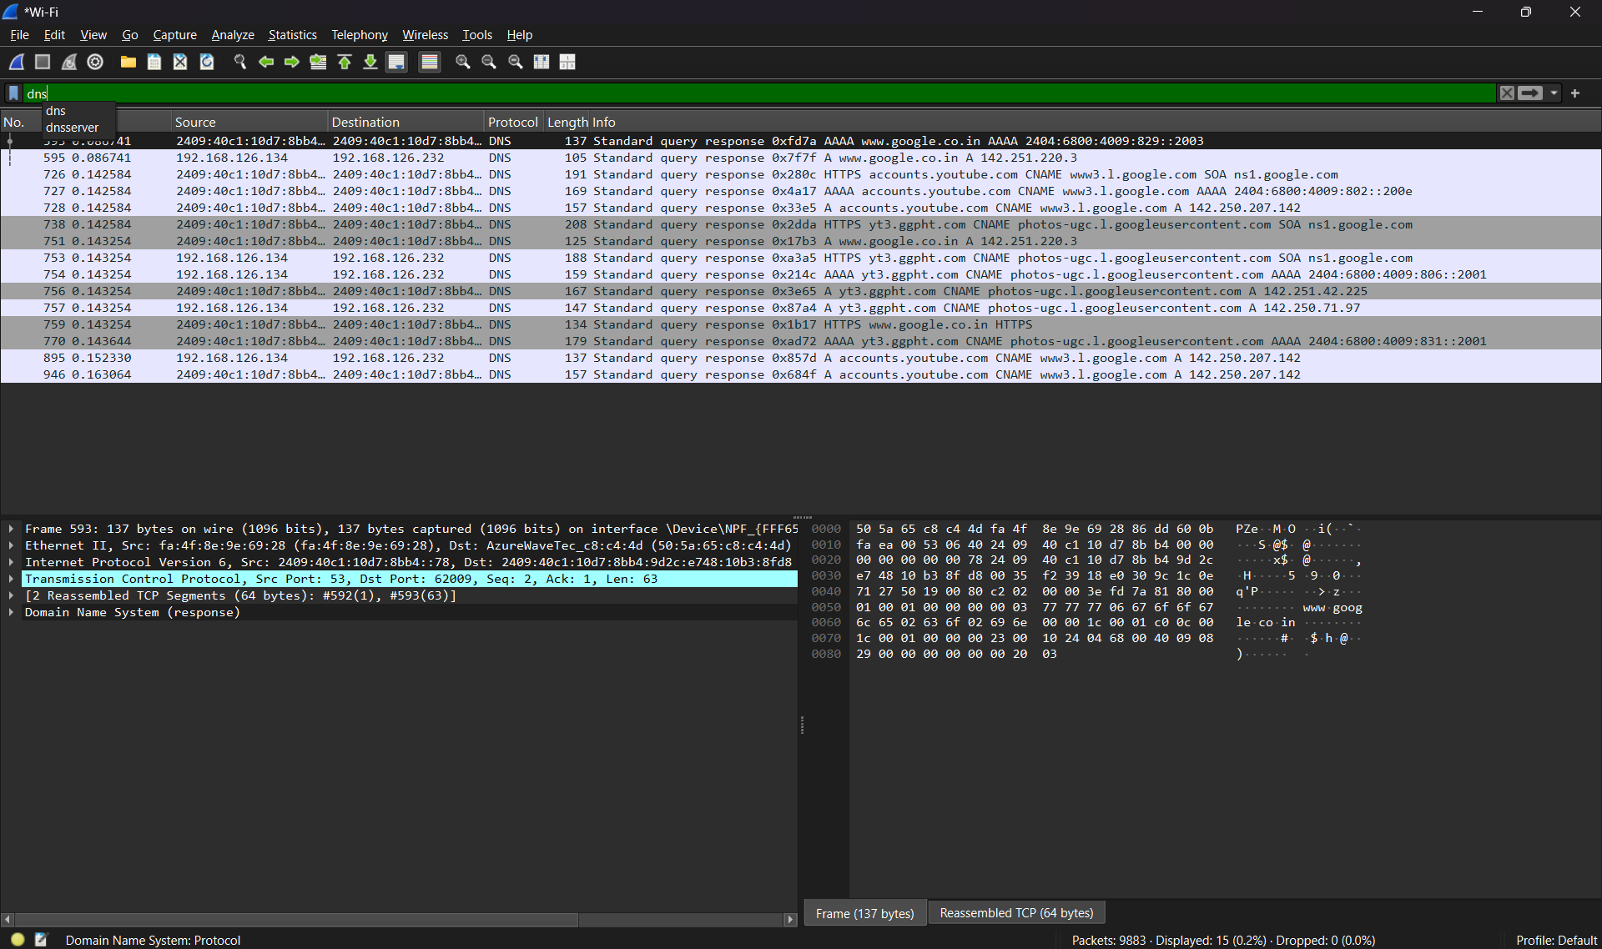

Filtering DNS protocol